Window Lifter
SW Component < Window Lifter >

History
Issue status  (Index) | Maturity/Date  (draft/invalid/valid)  (dd-mmm-yyyy) | Author  Department | Check/Release  Department | Description
1.0 | Draft  04-0ct-09 | Miguel Garcia | Miguel Garcia | Creation of the document
2.0 | Draft  Oct. 25, 2017 | Manuel Hernández | Manuel Hernández/Guilermo Hernández | Insertion of information on fields: Definitions and abbreviations, Realization constraints and targets, SW Conceptual design, Function description and dynamic behavior.
3.0 | Valid  Oct. 25, 2017 | Manuel Hernández | Manuel Hernández/Guilermo Hernández | Modification (actualization) of flux diagram with the overview of the Window lifter process. In section “SW Conceptual design”
4.0 | Valid  Oct. 25, 2017 | Guillermo Hernández | Manuel Hernández/Guilermo Hernández | Detailed descriptive table with static and dynamic behaviors. In section “Function Description and dynamic behavior”.
5.0 | Draft  Oct. 25, 2017 | Manuel Hernández | Manuel Hernández/Guilermo Hernández | Section 5. First Version of Functional Decomposition diagram showing the functions created and used, and the relationship between them.
6.0 | Draft  Oct. 25, 2017 | Guillermo  Hernández | Manuel Hernández/Guilermo Hernández | Section 2. Definitions and abbreviations updated, new functions added.  Section 2. References added (Document names and internet link)
7.0 | Draft  Oct. 25, 2017 | Guillermo Hernández | Manuel Hernández/Guilermo Hernández | Section 5.2. Functions static and dynamic descriptions. First version of tables with descriptions. No flux diagrams included yet.
8-0 | Draft  Oct. 26, 2017 | Manuel Hernández | Manuel Hernández/Guilermo Hernández | Section 5.1 Functional decomposition Update. First Version of “APP Layer – Block Definition Diagram” added.
9.0 | Draft  Oct. 29, 2017 | Manuel Hernández | Manuel Hernández/Guilermo Hernández | Section 5.2 .Functions static and dynamic behavior. Tables about EnableTimer500ms (void) were deleted, because a dedicated 500 ms validation was not necessary.
10.0 | Draft  Oct. 29, 2017 | Manuel Hernández | Manuel Hernández/Guilermo Hernández | Section 5.2 .Functions static and dynamic behavior. All diagrams related to the dynamic behavior of the function are included after each function.
11.0 | Draft  Oct. 29, 2017 | Manuel Hernández | Manuel Hernández/Guilermo Hernández | Section 2. Definitions and abbreviations. Deleted unused conceptual definitions from the table.  .Section 3. Realization constraints and targets. Deleted previows table, constraints and targets are correctly defined.  All sections. Foot images.

Table of Contents
1 Purpose 4
2 Definitions and abbreviations 4
2.1 Definitions 4
2.2 Abbreviations 4
2.3 References 4
3 Realization constraints and targets 5
3.1 About the objectives: 5
3.2 About the IDE: 5
3.3 About the development kit: 5
3.4 About the electronic components: 5
4 SW Conceptual design 6
5 SW Component internal breakdown 7
5.1 Functional Decomposition 7
5.2 Function Description and Dynamic Behavior. 8
5.3 Function static and dynamic behavior. 12
5.3.1 Down_Mode_Routine (&level) 12
5.3.2 Up_Mode_Routine (&level) 14
5.3.3 EnableTimer400ms () 16
5.3.4 DisableTimer400ms() 16
5.3.5 EnableTimer100ms() 16
5.3.6 DisableTimer100ms() 17
5.3.7 EnablePCC() 17
5.3.8 WindowInit () 18
5.3.9 IndicatorsInit () 19
5.3.10 ButttonsInit () 20
5.3.11 LPIT0_init () 21

Purpose
This document aims to present in a detailed way the software description and all of the components based on the requirements, to fulfill the Window lifter module as specified in “STR_WindowLifterModule.docx”.

Definitions and abbreviations

Definitions

Definition | Explanation
lpit0_ch0_flag_counter | Counter used at Timer0
one_touch_mode_flag | Flag to enable the one touch mode function
manual_mode_flag | Flag to enable the manual mode function
level | Variable that represent the state of the window (level of open/close)
pushup | Flag to represent that the pushup button was pressed
pushdown | Flag to represent that the pushdown button was pressed
PUSHUP | Variable referenced to the value of reading the state of the “Up Switch”
PUSHDOWN | Variable referenced to the value of reading the state of the “Down Switch”
Table 1. Variables and functions definitions.

Abbreviations

SW = “Software”

References

N° | Document name | Reference
1  2  3  4  5 | S32K- Reference Manual  S32K-User Guide  S32K- CookBook  S32K-DataSheet  S32K-QuickStartGuide (QSG) | https://www.nxp.com/products/microcontrollers-and-processors/arm-based-processors-and-mcus/s32-automotive-platform/s32k144-evaluation-board:S32K144EVB?tab=Documentation_Tab

Realization constraints and targets

The development team will deliver only the embedded software and physical components that satisfy the requirements established and revised in the “STR_WindowLifterModule.docx” and “Traceability_Matrix.xls” documents.

About the objectives:
To simulate the movement of a car’s window, with the functionalities:
- Validate a button press if the button is pressed for more than 10 msec.
- One touch mode (keep button pressed for less than 500 msec)
- Manual mode (keep button pressed for more than 500 msec).
- Anti-pinch (only available when the UP sequence in One Touch Mode is active)

About the IDE:
The software that will be used is the “S32 Design Studio for ARM v2.0” provided by NXT.

About the development kit:
The board in which the embedded software will be implemented is the S32K144EVB: Evaluation Board, also provided by NXT.

About the electronic components:
Component | Description | Quantity
10 LED bar | Red color | 1
330 ohm resistor (proposed) | To lower the voltage of the S32K144 EVB that will feed the LEDs bar. | 10
0.1 uF capacitor (optional) | Capacitor that will filter the noise caused by the bounce of the “pinch” pushbutton.. | 1
External pushbutton (proposed) | Pushbutton dedicated for the “Pinch” signal. | 1
10 kOhm resistor (proposed) | Pullup resistor to work with the Anti pinch pushbutton. | 1
Jumper male-to-male cable (proposed) | Jumper that will allow the signal to turn on the LEDs from the NXT development PCB to the 10 LED bar. One more jumpers will be used also to communicate the NXP board with the “Pinch” pushbutton. Two more will provide +5V DC and GND to the protoboard in which the circuit will be implemented. | 13
Proto-board (proposed) | In the early stages of the development of the Window Lifter module, this will serve to implement the external circuitry. | 1
Table 2. Electronic components for the Window lifter module.

SW Conceptual design
Note: To have a good and nitid view of the diagram, please zoom until desired clarity is reached, given that the image is a *.png file.

Image 1. Conceptual functional design.

SW Component internal breakdown

Functional Decomposition
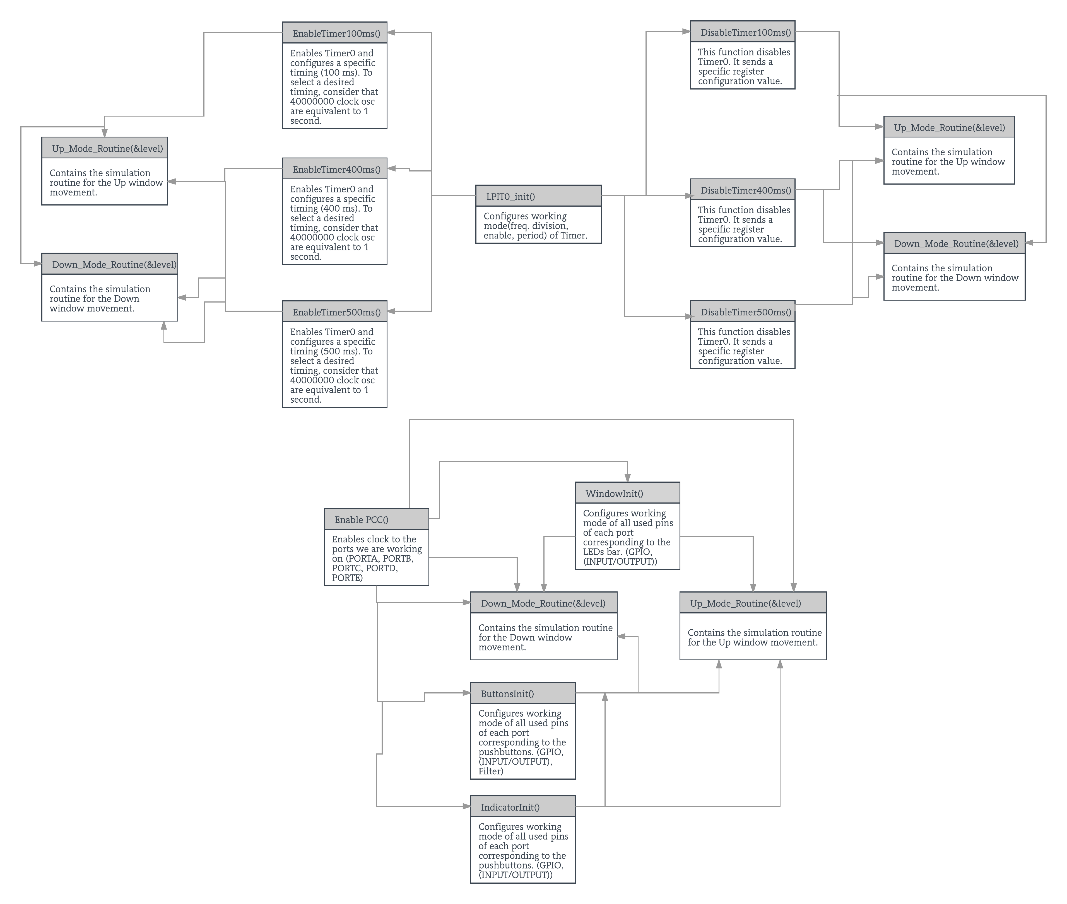
Image 2. Static tree of functions.

Function Description and Dynamic Behavior.
Functionality | Behavior
Down_Mode_Routine | Static Description:  Esta función contiene la rutina de simulación de bajada de ventana (LEDS)  Dynamic Description:  Rutina formada por una estructura SWITCH-CASE.  Evalua una variable (level) que actua como contador y ejemplifica el nivel de apertura/cierre de la ventana.  Cada que termina un estado CASE, el valor de la variable “level” disminuye en 1
Up_Mode_Routine | Static Description:  Esta function contiene la rutina de simulacion de subida de ventana (LEDS)  Dynamic Description:  Rutina formada por una estructura SWITCH-CASE.  Evalua una variable (level) que actua como contador y ejemplifica el nivel de apertura/cierre de la ventana.  Cada que termina un estado CASE, el valor de la variable “level” aumenta en 1
EnableTimer400ms | Static Description:  Esta funcion habilita el Timer0 y configura una velocidad especifica de conteo (400ms)  Para seleccionar la velocidad deseada, se toma en cuenta que 40000000 oscilaciones de reloj == 1seg.  Dynamic Description:  Establece la configuración del Timer0  Manda LPIT0->TMR[0].TCTRL = 0x00000001; lo cual habilita el Timer.  Manda LPIT0->TMR[1].TVAL = 16000000; lo cual especifica la velocidad de trabajo a 400 ms
DisableTimer400ms | Static Description:  Esta función deshabilita el Timer0.  Manda un valor de configuración especifico  Dynamic Description:  Manda LPIT0->TMR[0].TCRL = 0x00000001; lo cual especifica la deshabilitacion del Timer0
EnableTimer10ms | Static Description:  Esta funcion habilita el Timer0 y configura una velocidad especifica de conteo (10ms)  Para seleccionar la velocidad deseada, se toma en cuenta que 40000000 oscilaciones de reloj == 1seg.  Dynamic Description:  Establece la configuración del Timer0  Manda LPIT0->TMR[0].TCTRL = 0x00000001; lo cual habilita el Timer.  Manda LPIT0->TMR[0].TVAL = 4000000; lo cual especifica la velocidad de trabajo a 10 ms
DisableTimer10ms | Static Description:  Esta función deshabilita el Timer0.  Manda un valor de configuración especifico  Dynamic Description:  Manda LPIT0->TMR[0].TCRL = 0x00000001; lo cual especifica la deshabilitacion del Timer0
EnablePCC | Static Description:  Funcion encargada de habilitar el reloj a los puertos con los que trabajaremos. (PORTA,PORTB,PORTC,PORTD,PORTE)  Dynamic Description:  Establece una configuracion especifica :  PCC-> PCCn[PCC_PORTX_INDEX] = PCC_PCCn_CGC_MASK;  (X = Puerto especifico a configurar)  (PCC_PCCn_CGC_MASK == 0x40000000u . El cual es el valor especifico para la configuracion)
WindowInit | Static Description:  Funcion encargada de configurar modo de trabajo (GPIO & (INPUT/OUTPUT) ) de los pines de cada puerto (Los utilizados para la simulación de la ventana con LEDs).  Dymanic Description:  PTX->PDDR |= 1<<PTBX; . Establece ese pin como OUTPUT, al ponerle un 1 (X= pin y puerto especifico)  PORTX->PCR[PTBX] = 0x00000100; . Establece el puerto y el pin especifico como GPIO  (X= pin y puerto especifico)  (0x00000100 = configuracion GPIO)
IndicatorsInit | Static Description:  Funcion encargada de configurar modo de trabajo ( GPIO & (INPUT/OUTPUT) ) de los pines de cada puerto (Los utilizados para los indicadores UP/DOWN).  Dymanic Description:  PTX->PDDR |= 1<<PTBX; . Establece ese pin como OUTPUT, al ponerle un 1 (X= pin y puerto especifico)  PORTX->PCR[PTBX] = 0x00000100; . Establece el puerto y el pin especifico como GPIO  (X= pin y puerto especifico)  (0x00000100 = configuracion GPIO)
ButtonsInit | Static Description:  Funcion encargada de configurar modo de trabajo ( GPIO & (INPUT/OUTPUT) & Filter ) de los pines de cada puerto (Los utilizados para la detección de los switch).  Dymanic Description:  PTX->PDDR &= ~(1<<PTCX);  . Establece ese pin como INPUT,(X= pin y puerto especifico)  PORTC->PCR[PTC12] = 0x00000110; . Establece el puerto con input filter  (X= pin y puerto especifico)  (0x00000110 = configuracion FILTER)
LPIT0_init | Static Description:  Funcion encargada de configurar modo de trabajo ( Division de Freq., Habilitar, Periodo ) de Timer  Dymanic Description:  PCC->PCCn[PCC_LPIT_INDEX] = PCC_PCCn_PCS(6);  (Division de Freq. Reloj = Configuracion 6)  PCC->PCCn[PCC_LPIT_INDEX] |= PCC_PCCn_CGC_MASK; /* Enable clk to LPIT0 regs */  (Habilitar Reloj a Registros de Timer)  LPIT0->MIER = 0x00000001;  (Habilitar Interrupciones a Canal 0 Timer)  LPIT0->TMR[0].TVAL = 4000000;  (Configurar Freq. de Trabajo *40000000 = 1 second*)  LPIT0->TMR[0].TCTRL = 0x00000000;  (Deshabilitar el Timer)
EnableTimer500ms | Static Description:  Esta funcion habilita el Timer0 y configura una velocidad especifica de conteo (500ms)  Para seleccionar la velocidad deseada, se toma en cuenta que 40000000 == 1seg.  Dynamic Description:  Establece la configuración del Timer0  Manda LPIT0->TMR[0].TCTRL = 0x00000001; lo cual habilita el Timer.  Manda LPIT0->TMR[1].TVAL = 20000000; lo cual especifica la velocidad de trabajo
DisableTimer500ms | Static Description:  Esta función deshabilita el Timer0.  Manda un valor de configuración especifico  Dynamic Description:  Manda LPIT0->TMR[0].TCRL = 0x00000001; lo cual especifica la deshabilitacion del Timer0

Table 3. Function description and dynamic behavior.

Function static and dynamic behavior.

Down_Mode_Routine (&level)

Description | This function works with a switch-case structure.  Evaluate the parameter “level”, and decide which case shall enter.  After the “break” of each case, the parameter “level” has increased its value and the routine is repeated.
Parameter 1  <input| output| inout> | Parameter “level” is an int variable that is used as a counter. The parameter is given to the function as a pointer
Parameter 2..n | - -
Return Value | This function has no return value, because it uses the parameter “level” only to evaluate it
Precondition | This function can only be called in a certain state, defined by other function in the SW.  Evaluation of the value of the parameter (&level)
Post condition | Change the value of a variable that controls the LED State  Change the value of the parameter (level is a counter )
Error Conditions | The error conditions were analyzed and a “default” state was included to solve it

Image 3. Down Mode Routine function dynamic behavior.

Up_Mode_Routine (&level)

Description | This function works with a switch-case structure.  Evaluate the parameter “level”, and decide which case shall enter.  After the “break” of each case, the parameter “level” has increased its value and the routine is repeated.
Parameter 1  <input| output| inout> | Parameter “level” is an int variable that is used as a counter. The parameter is given to the function as a pointer
Parameter 2..n | - -
Return Value | This function has not return value, because use the parameter just to evaluate it
Precondition | This function can only be called in a certain state, defined by other function in the SW.  Evaluation of the value of the parameter (&level)
Post condition | Change the value of a variable that control a LED State  Change the value of the parameter (level is a counter )
Error Conditions | The error conditions were analyzed and a “default” state was included to solve it

Image 4. Up Mode Routine function dynamic behavior.

EnableTimer400ms ()

(si no fuera necesaria la table de static, o bien, esto no fuera static, referenciar el diagrama como 5.3.3)
5.3.3.1 Static Behavior
Description |  | This function enables the Timer0 and configure the specific frequency to work with.
Parameter 1  <input| output| inout> |  | There´s no parameter to use in this function
Parameter 2..n
Return Value |  | --
Precondition |  | The value of the registers (of Timer0) are the default value.
Post condition |  | Change the specific values of the registers (of Time0) to work with
Error Conditions |  | --

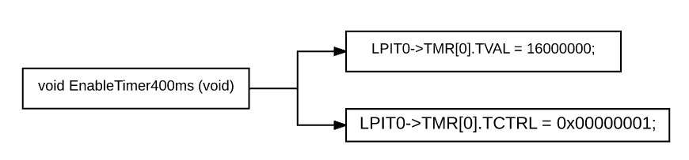
5.3.3.2. Image 5. EnableTimer400ms function dynamic behavior.

DisableTimer400ms()

Description | This function disable the Timer0
Parameter 1  <input| output| inout> | There´s no parameter to use in this function
Parameter 2..n
Return Value | --
Precondition | The value of the registers (of Timer0) are the specific to work with.
Post condition | Change the specific values of the registers (of Time0) to enable it
Error Conditions | --

Image 6. DisableTimer400ms function dynamic behavior.

EnableTimer100ms()

Description | This function enable the Timer0 and configure the specific frequency to work
Parameter 1  <input| output| inout> | There´s no parameter to use in this function
Parameter 2..n
Return Value | --
Precondition | The value of the registers (of Timer0) are the default value.
Post condition | Change the specific values of the registers (of Time0) to work with
Error Conditions | --

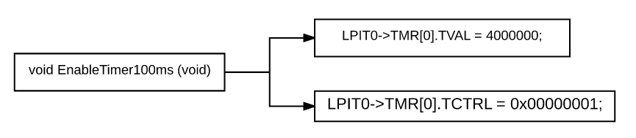
Image 7. EnableTimer100ms function dynamic behavior.

DisableTimer100ms()

Description | This function disable the Timer0
Parameter 1  <input| output| inout> | There´s no parameter to use in this function
Parameter 2..n
Return Value | --
Precondition | The value of the registers (of Timer0) are the specific to work with.
Post condition | Change the specific values of the registers (of Time0) to enable it
Error Conditions | --

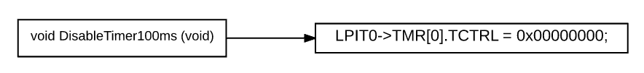
Image 8. DisableTimer100ms function dynamic behavior.

EnablePCC()

Description | This function enable and configure the clock signal on the ports used on the SW.
Parameter 1  <input| output| inout> | There´s no parameter to use in this function
Parameter 2..n
Return Value | --
Precondition | The value of the configuration (clock) to the ports are the default value.
Post condition | Change the specific values of the configuration (clock) to the ports to work with
Error Conditions | --

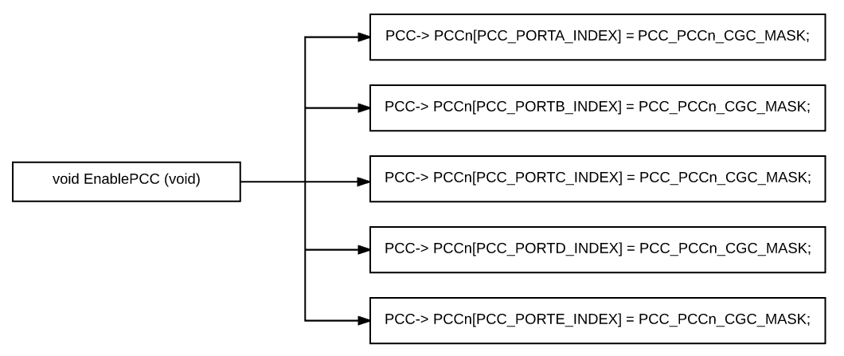
Image 9. EnablePCC function dynamic behavior.

WindowInit ()

Description | This function enable and configure the specific pins of the port used to simulate the behavior of the Window
Parameter 1  <input| output| inout> | There´s no parameter to use in this function
Parameter 2..n
Return Value | --
Precondition | The value of the configuration (mode) of the ports are the default value.
Post condition | Change the specific values of the configuration (mode) of the ports to work with
Error Conditions | --

Image 10. WindowInit function dynamic behavior.

IndicatorsInit ()

Description | This function enable and configure the specific pins of the port used to the indicator of the Function mode (Up/Down)
Parameter 1  <input| output| inout> | There´s no parameter to use in this function
Parameter 2..n
Return Value | --
Precondition | The value of the configuration (mode) of the ports are the default value.
Post condition | Change the specific values of the configuration (mode) of the ports to work with
Error Conditions | --

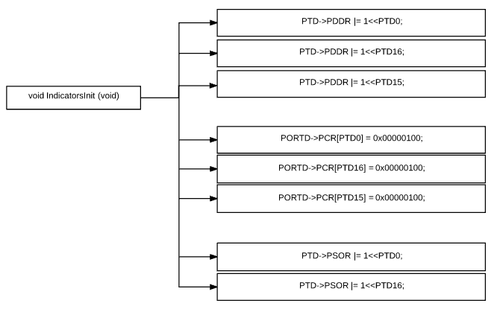
Image 11. IndicatorsInit function dynamic behavior.

ButttonsInit ()

Description | This function enable and configure the specific pins of the ports used to detect the switch signals (GPIO, Input,Output,Filter)
Parameter 1  <input| output| inout> | There´s no parameter to use in this function
Parameter 2..n
Return Value | --
Precondition | The value of the configuration (mode) of the ports are the default value.
Post condition | Change the specific values of the configuration (mode) of the ports to work with
Error Conditions | --

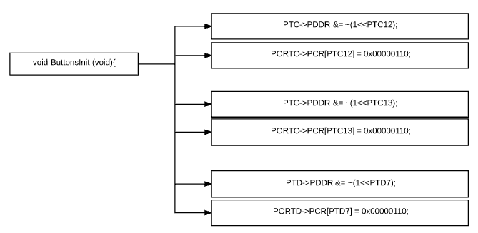
Image 12. ButtonsInit function dynamic behavior.

LPIT0_init ()

Description | This function enable and configure the specific working mode of the Timer (Frequency, Enable)
Parameter 1  <input| output| inout> | There´s no parameter to use in this function
Parameter 2..n
Return Value | --
Precondition | The value of the configuration (mode) of the ports are the default value.
Post condition | Change the specific values of the configuration (mode) of the Timer to work with
Error Conditions | --

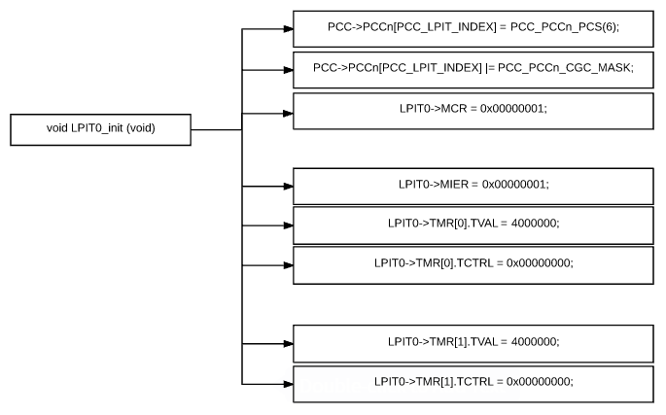
Image 13. LPIT0_init function dynamic behavior.

